ASSIGNMENT-12

WORD CLOUD

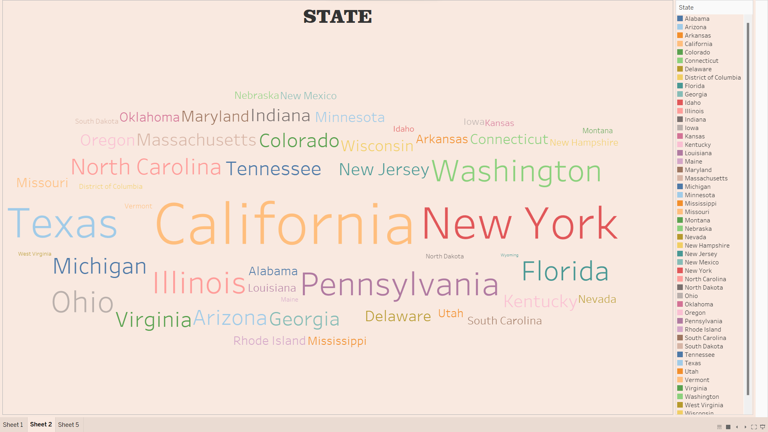

CONTROL CHART

